**ROOM COUNSELLING AID**

***2 CREDIT COURSE GDG VIT***

***PROJECT***

***by***

***BHUVANESH ARVINDH JV (16MIS0248)***



**VIT University, Vellore**

**Tamil Nadu - 632 014**

**Winter Semester :2018 -2019**

**MARCH-2019**

**ABSTRACT**

The hostel room counselling is carried out by VIT every year. This counselling is purely based on **NCGPA ranking** . one who don’t have any idea for choosing the roommates or one who are in the need of help will be make use of this portal. In this web portal students can **start a campaign for getting the roommates** and where people can find the suitable hosts to incorporate them into the rooms .

**INTRODUCTION**

* As we are know that hostel room counseling is carried out by VIT every year for all the hostel students .
* This counseling is purely based on NCGPA ranking . (the highest cgpa among all the students put to gether in the hostel. Irrespective of any branches.).
* The highest CGPA or NCGPA student will be called first. They take room according to their preference.
* The remaining blocks and rooms are filled accordingly.
* The student can prefer any floor, any block, any type of room.
* Be it ac/non Ac . Single, double, 4 bedded, 6 bedded.Finally, if any of your close buddies have the highest cgpa or ncgpa please go along with them. If they wish they can share their room with you.
* for eg. If your ncgpa is 8.9 and your friend’s ncgpa is 9.8. may be she/he gets a call before you. You can join them(it is not possible if she/he prefers single bedded)since it cannot be shared.
* In this situation many of them don’t know how to choose their roommates . here we are helping them to choose their roommates by creating the portal called **ROOM COUNSELLING AID (RCA)**.
* In this web portal students can start a campaign for getting the roommates and where people can find the suitable hosts to incorporate them into the rooms . after they find out who is their roommate they can also chat with them and discuss about the counselling and other information.

**METHODOLOGY**

* Here students can sign up the account and login to the portal. Followed by they can start their own campaign . then they can see others campaign by seeing their NCGPA rank, image , need , room type, block etc and choose who is their ideal roommate and they can chat with them . they can also print the report of each and every block for their own convenience . they can also see all the users of this portal .
* And for the chat part is very well secured by hashing and encryption .
* User message is hashed then encrypted by AES algorithm and stored in database. And decrypted message is again hashed and check with first hashed message . if it equals only it will display the message .
* Here is the block diagram of ROOM COUNSELLING AID (RCA)

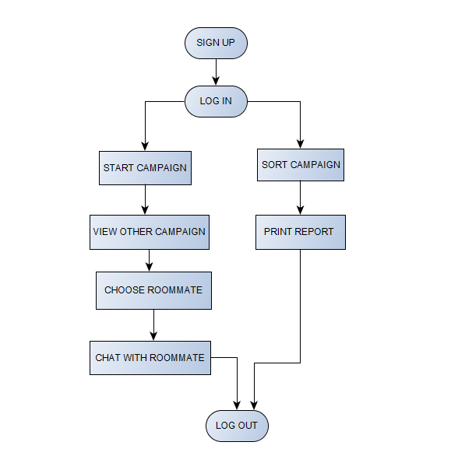

**Step by step process:**

* Step 0: sign up
* Step 1: login
* Step 2: start your own campaign
* Step 3: view other campaign
* Step 4: choose your roommate
* Step 5:chat with your roommate
* Step 6:sort the campaign based on block
* Step 7: print the report
* Step 8: log out

Here I am using MYSQl for backend and WAMP server

**RESULT**

Here I enclosed all the screenshots of my portal step by step

Includes login , signup ,home page , start campaign,add details , view users , sort and print , menu , head name , chat .

Here I faced difficulty in chat encryption and database retrieval .

**Login** 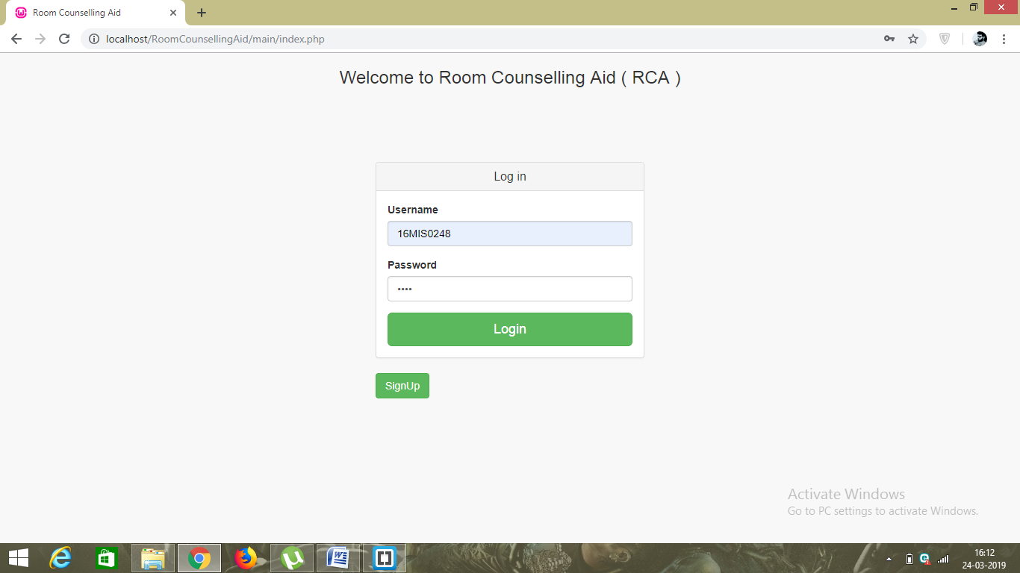

**Sign up**

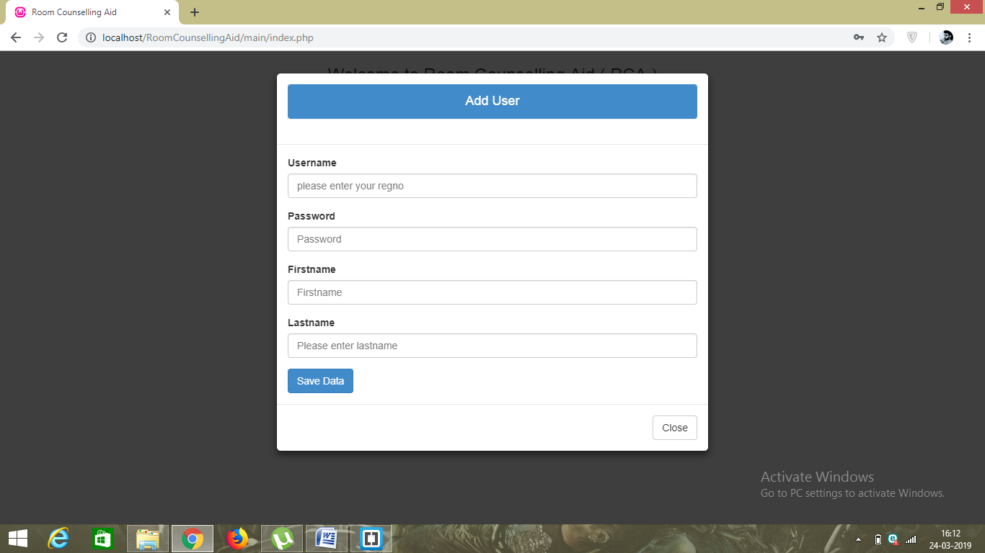

**Home page and view others campaign** 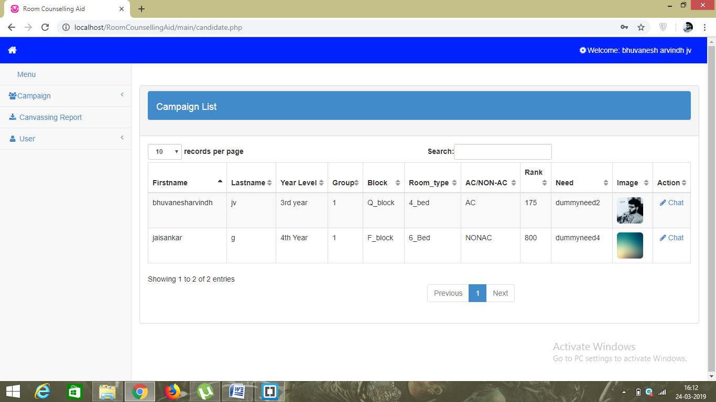

**Start campaign**

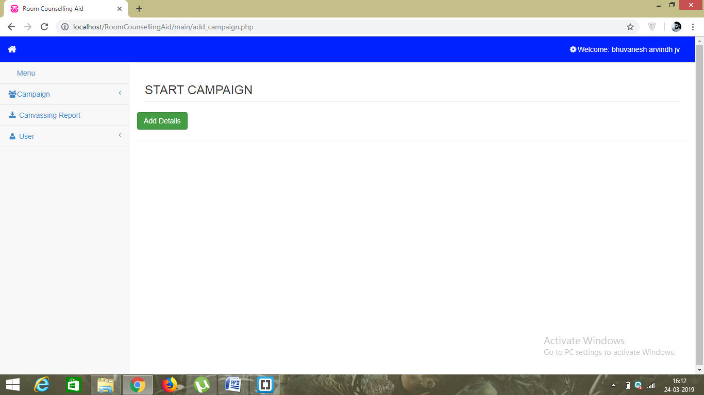

**Add details for campaign**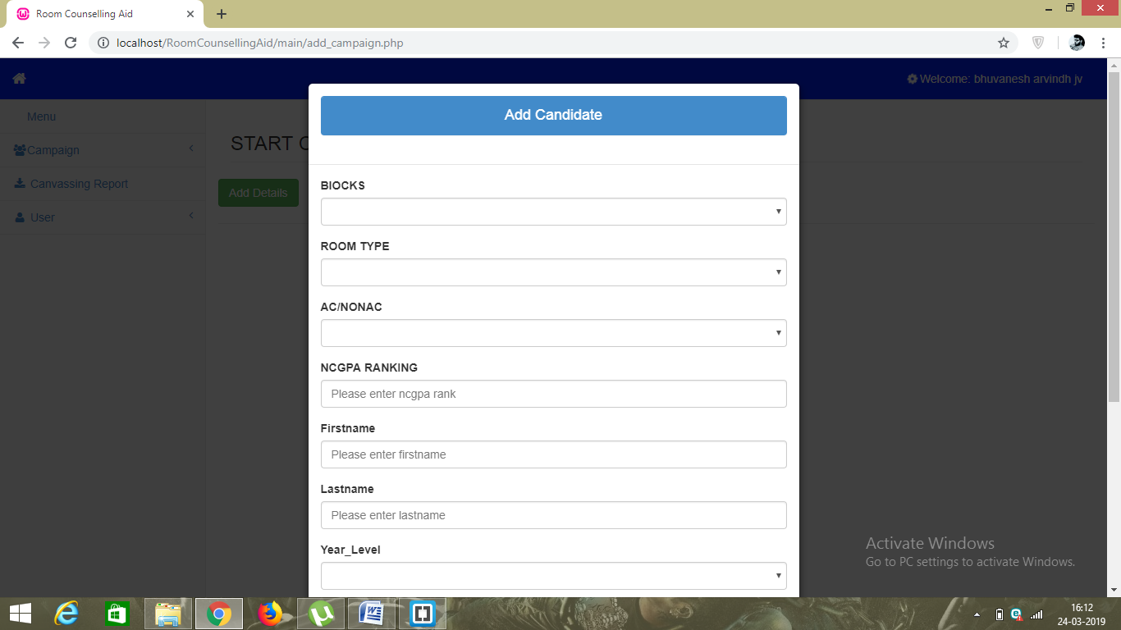

**View users**

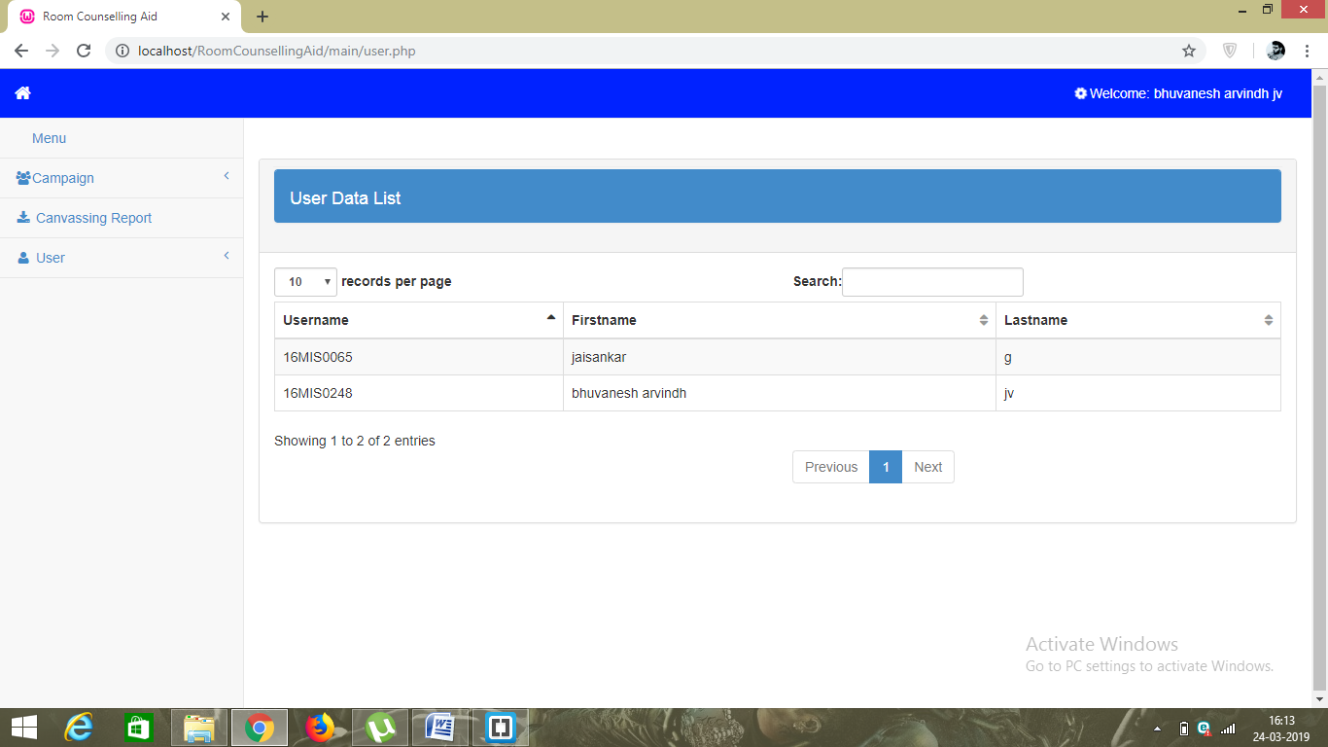

**Sort and print the all campaign details** 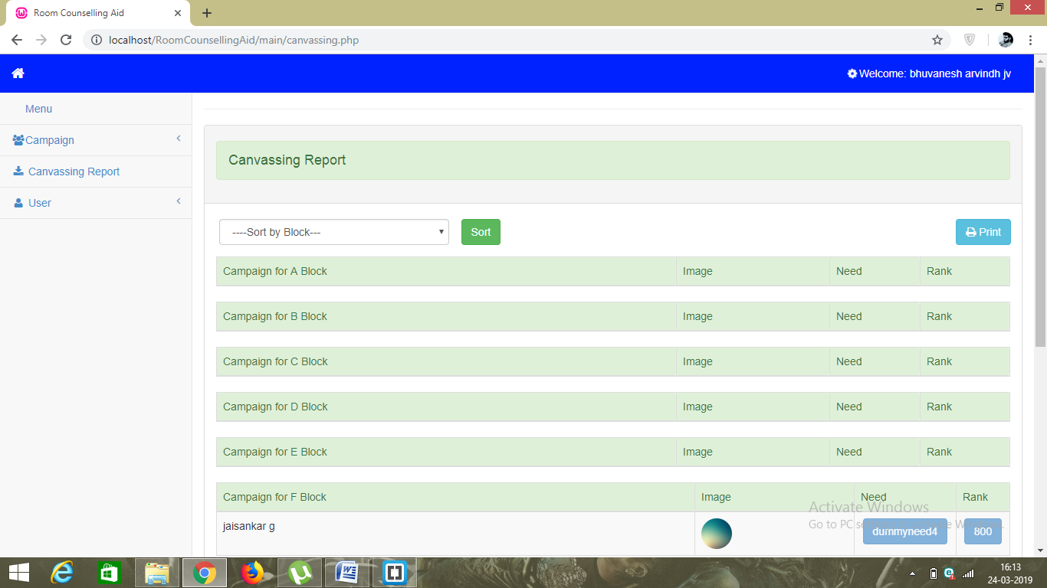

**Sorted according to q block**

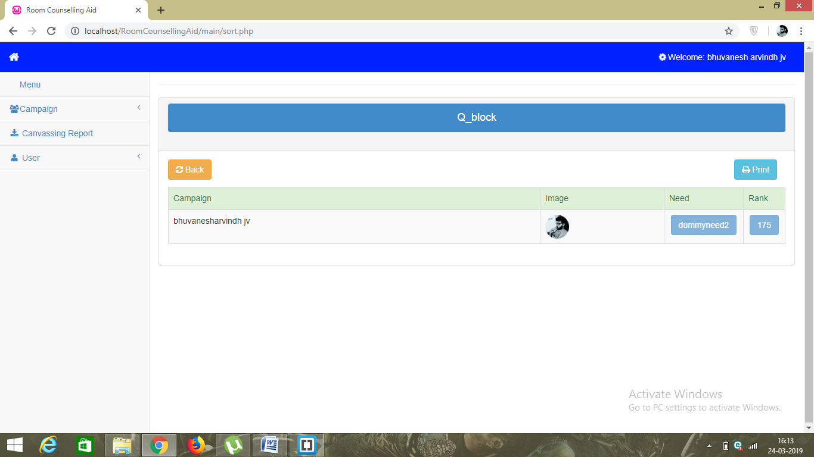

**Secured chat** 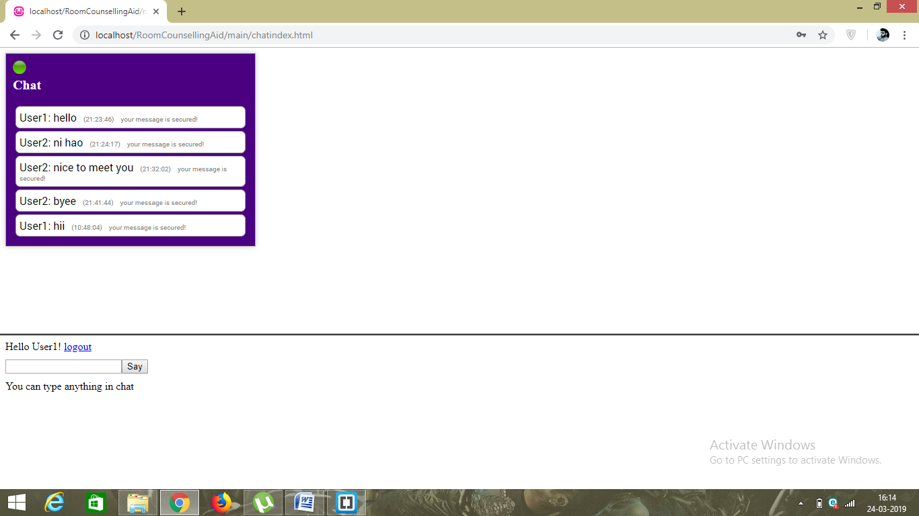

**Menu**

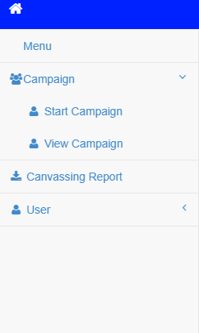

**Head name**

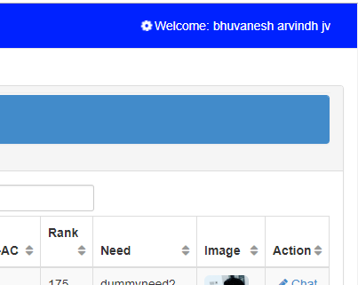

**CONCLUSION**

I concludes that one who don’t have any idea for choosing the roommates or one who are in the need of help will be make use of this portal. In this web portal students can start a campaign for getting the roommates and where people can find the suitable hosts to incorporate them into the rooms .

This portal will be very helpful for the hostel room counselling in VIT .